CIVIL ENGINEERING
VISION
To develop efficient Civil Engineering professionals who serve competently, collaboratively, and ethically to create a sustainable world and enhance the quality of life.
MISSION
- M1: To impart quality education & practical training in collaboration with industry through prescribed curriculum.
- M2: To develop professionally skilled and ethical planners, designers & constructors.
- M3: To develop leadership skills in decision making while shaping public, environmental & infrastructure policy.
Program Educational Objectives Statements
- PEO1: To apply technical knowledge in analyzing problems in the field of civil engineering, with maximum economic benefits to society and minimum damage to the environment.
- PEO2: To enhance soft skills, which will enable them to work as leaders, team members and contribute to nation building.
- PEO3: To make them committed to professional ethics and focus on ensuring quality ,safety and environmental sustainability in all their professional activities.
FROM HOD’S DESK
- The Civil Engineering Department was established in the year 2007, recognized by DTE, Bengaluru and affiliated to AICTE, New Delhi. The current intake is 40 students.
- The department is committed to educating the students in the field of Civil Engineering, with professional skills and ethical values through teaching- learning process and develop them to face the societal challenges and to meet the needs of the stakeholders.
- The program has well-equipped Civil Engineering laboratories with adequate facilities and high end equipments.
- As a part of academic curriculum, students take up industrial visit and internship, to augment much needed practical exposure.
- Guest lectures by personnel from industry, entrepreneurs, and researchers in the field of Civil Engineering.
- Many students are serving at reputed organizations like RAMCO, Shobha Constructions and those who are pursuing higher studies are studying in prestigious Engineering colleges, like PESIT SJCE, NIE.
- Staff and students are provided with unlimited free internet access at e-Library during spare time, so that they can develop and enhance their knowledge acquired in class rooms.
note: All the faculties nature of association is regular Employees
LIST OF TEACHING FACULTY
SL No. | Image | NAME | DESIGNATION | QUALIFICATION | Date of Joining | Profile
1 | 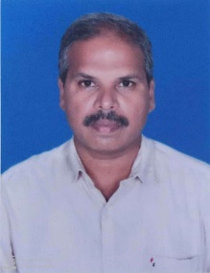 | Mahadevaprabhu K M | HOD | BE | 13/7/2009 | click here to view
2 | 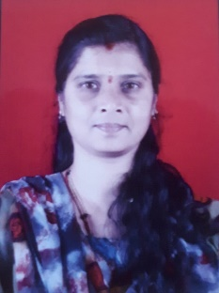 | Bhavya M | Lecturer | MTech. | 03-10-2011 | click here to view
3 |  | Akshay kumar S | Lecturer | MTech. | 10-10-2013 | click here to view
4 | 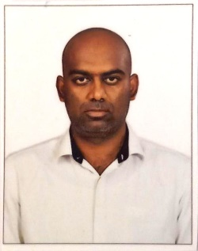 | Roopeshkumar B | Lecturer | MTech. | 16/7/2014 | click here to view
5 | 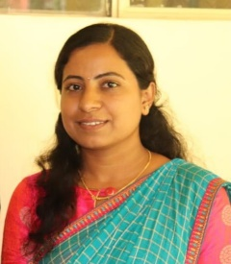 | Yogitha H M | Lecturer | BE | 02-04-2016 | click here to view

LIST OF SUPPORTING STAFF
SL No. | Image | NAME | DESIGNATION | QUALIFICATION
1 | 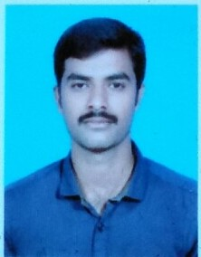 | Manju B | Lab helper | ITI
2 |  | Basavanna | Lab helper | ITI

